DAY-6

NAME-NAINSI

UID-22BCS15333

DATE_26/12/2024

Question 1

#include <iostream>

#include <vector>

using namespace std;

struct TreeNode {

int val;

TreeNode* left;

TreeNode* right;

TreeNode() : val(0), left(nullptr), right(nullptr) {}

TreeNode(int x) : val(x), left(nullptr), right(nullptr) {}

TreeNode(int x, TreeNode* left, TreeNode* right) : val(x), left(left), right(right) {}

};

void inorderTraversalHelper(TreeNode* root, vector<int>& result) {

if (root == nullptr) {

return;

}

inorderTraversalHelper(root->left, result);

result.push_back(root->val);

inorderTraversalHelper(root->right, result);

}

vector<int> inorderTraversal(TreeNode* root) {

vector<int> result;

inorderTraversalHelper(root, result);

return result;

}

int main() {

TreeNode* root = new TreeNode(1);

root->right = new TreeNode(2);

root->right->left = new TreeNode(3);

vector<int> result = inorderTraversal(root);

for (int val : result) {

cout << val << " ";

}

delete root->right->left;

delete root->right;

delete root;

return 0;

}

Output:

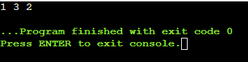

Question 2

#include <iostream>

#include <cmath>

using namespace std;

struct TreeNode {

int val;

TreeNode* left;

TreeNode* right;

TreeNode() : val(0), left(nullptr), right(nullptr) {}

TreeNode(int x) : val(x), left(nullptr), right(nullptr) {}

TreeNode(int x, TreeNode* left, TreeNode* right) : val(x), left(left), right(right) {}

};

int computeDepth(TreeNode* node) {

int depth = 0;

while (node) {

depth++;

node = node->left;

}

return depth;

}

int countNodes(TreeNode* root) {

if (!root) return 0;

int leftDepth = computeDepth(root->left);

int rightDepth = computeDepth(root->right);

if (leftDepth == rightDepth) {

return (1 << leftDepth) + countNodes(root->right);

} else {

return (1 << rightDepth) + countNodes(root->left);

}

}

int main() {

// Example usage:

TreeNode* root = new TreeNode(1);

root->left = new TreeNode(2);

root->right = new TreeNode(3);

root->left->left = new TreeNode(4);

root->left->right = new TreeNode(5);

root->right->left = new TreeNode(6);

cout << "Number of nodes: " << countNodes(root) << endl;

delete root->left->left;

delete root->left->right;

delete root->right->left;

delete root->left;

delete root->right;

delete root;

return 0;

}

Output:

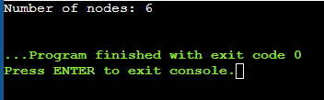

Question 3

#include <iostream>

using namespace std;

struct TreeNode {

int val;

TreeNode* left;

TreeNode* right;

TreeNode() : val(0), left(nullptr), right(nullptr) {}

TreeNode(int x) : val(x), left(nullptr), right(nullptr) {}

TreeNode(int x, TreeNode* left, TreeNode* right) : val(x), left(left), right(right) {}

};

int maxDepth(TreeNode* root) {

if (!root) return 0;

int leftDepth = maxDepth(root->left);

int rightDepth = maxDepth(root->right);

return max(leftDepth, rightDepth) + 1;

}

int main() {

TreeNode* root = new TreeNode(1);

root->left = new TreeNode(2);

root->right = new TreeNode(3);

root->left->left = new TreeNode(4);

root->left->right = new TreeNode(5);

root->right->right = new TreeNode(6);

cout << "Maximum Depth: " << maxDepth(root) << endl;

delete root->left->left;

delete root->left->right;

delete root->right->right;

delete root->left;

delete root->right;

delete root;

return 0;

}

Output:

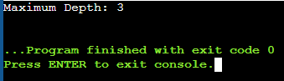

Question 4

#include <iostream>

#include <vector>

#include <unordered_map>

using namespace std;

struct TreeNode {

int val;

TreeNode* left;

TreeNode* right;

TreeNode() : val(0), left(nullptr), right(nullptr) {}

TreeNode(int x) : val(x), left(nullptr), right(nullptr) {}

TreeNode(int x, TreeNode* left, TreeNode* right) : val(x), left(left), right(right) {}

};

TreeNode* buildTreeHelper(vector<int>& preorder, int preStart, int preEnd,

vector<int>& inorder, int inStart, int inEnd,

unordered_map<int, int>& inorderIndexMap) {

if (preStart > preEnd || inStart > inEnd) {

return nullptr;

}

int rootVal = preorder[preStart];

TreeNode* root = new TreeNode(rootVal);

int rootIndex = inorderIndexMap[rootVal];

int leftSubtreeSize = rootIndex - inStart;

root->left = buildTreeHelper(preorder, preStart + 1, preStart + leftSubtreeSize,

inorder, inStart, rootIndex - 1, inorderIndexMap);

root->right = buildTreeHelper(preorder, preStart + leftSubtreeSize + 1, preEnd,

inorder, rootIndex + 1, inEnd, inorderIndexMap);

return root;

}

TreeNode* buildTree(vector<int>& preorder, vector<int>& inorder) {

unordered_map<int, int> inorderIndexMap;

for (int i = 0; i < inorder.size(); i++) {

inorderIndexMap[inorder[i]] = i;

}

return buildTreeHelper(preorder, 0, preorder.size() - 1,

inorder, 0, inorder.size() - 1,

inorderIndexMap);

}

void printInorder(TreeNode* root) {

if (!root) return;

printInorder(root->left);

cout << root->val << " ";

printInorder(root->right);

}

int main() {

vector<int> preorder = {3, 9, 20, 15, 7};

vector<int> inorder = {9, 3, 15, 20, 7};

TreeNode* root = buildTree(preorder, inorder);

cout << "Inorder traversal of the constructed tree: ";

printInorder(root);

return 0;

}

Output:

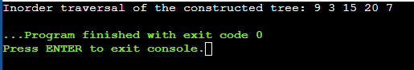

Question 5

#include <iostream>

using namespace std;

struct TreeNode {

int val;

TreeNode* left;

TreeNode* right;

TreeNode(int x) : val(x), left(nullptr), right(nullptr) {}

};

TreeNode* lowestCommonAncestor(TreeNode* root, TreeNode* p, TreeNode* q) {

if (!root) return nullptr;

if (root == p || root == q) return root;

TreeNode* left = lowestCommonAncestor(root->left, p, q);

TreeNode* right = lowestCommonAncestor(root->right, p, q);

if (left && right) {

return root;

}

return left ? left : right;

}

int main() {

TreeNode* root = new TreeNode(3);

root->left = new TreeNode(5);

root->right = new TreeNode(1);

root->left->left = new TreeNode(6);

root->left->right = new TreeNode(2);

root->right->left = new TreeNode(0);

root->right->right = new TreeNode(8);

root->left->right->left = new TreeNode(7);

root->left->right->right = new TreeNode(4);

TreeNode* p = root->left;

TreeNode* q = root->left->right->right;

TreeNode* lca = lowestCommonAncestor(root, p, q);

if (lca) {

cout << "Lowest Common Ancestor of " << p->val << " and " << q->val << " is: " << lca->val << endl;

} else {

cout << "No common ancestor found." << endl;

}

return 0;

}

Output:

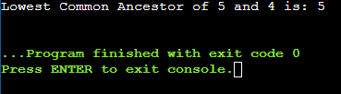

Question 6

#include <iostream>

#include <vector>

#include <queue>

using namespace std;

struct TreeNode {

int val;

TreeNode* left;

TreeNode* right;

TreeNode(int x) : val(x), left(nullptr), right(nullptr) {}

};

vector<vector<int>> levelOrder(TreeNode* root) {

vector<vector<int>> result;

if (!root) return result;

queue<TreeNode*> q;

q.push(root);

while (!q.empty()) {

int levelSize = q.size();

vector<int> currentLevel;

for (int i = 0; i < levelSize; i++) {

TreeNode* node = q.front();

q.pop();

currentLevel.push_back(node->val);

if (node->left) q.push(node->left);

if (node->right) q.push(node->right);

}

result.push_back(currentLevel);

}

return result;

}

int main() {

TreeNode* root = new TreeNode(3);

root->left = new TreeNode(9);

root->right = new TreeNode(20);

root->right->left = new TreeNode(15);

root->right->right = new TreeNode(7);

vector<vector<int>> traversal = levelOrder(root);

cout << "Level Order Traversal:" << endl;

for (const auto& level : traversal) {

for (int val : level) {

cout << val << " ";

}

cout << endl;

}

return 0;

}

Output:

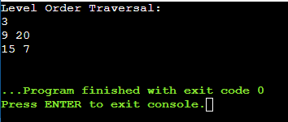

Question 7

#include <iostream>

using namespace std;

struct TreeNode {

int val;

TreeNode* left;

TreeNode* right;

TreeNode(int x) : val(x), left(nullptr), right(nullptr) {}

};

bool hasPathSum(TreeNode* root, int targetSum) {

if (!root) return false;

if (!root->left && !root->right) {

return root->val == targetSum;

}

int remainingSum = targetSum - root->val;

return hasPathSum(root->left, remainingSum) || hasPathSum(root->right, remainingSum);

}

int main() {

TreeNode* root = new TreeNode(5);

root->left = new TreeNode(4);

root->right = new TreeNode(8);

root->left->left = new TreeNode(11);

root->right->left = new TreeNode(13);

root->right->right = new TreeNode(4);

root->left->left->left = new TreeNode(7);

root->left->left->right = new TreeNode(2);

root->right->right->right = new TreeNode(1);

int targetSum = 22;

if (hasPathSum(root, targetSum)) {

cout << "Yes, there is a root-to-leaf path with the sum " << targetSum << "." << endl;

} else {

cout << "No, there is no root-to-leaf path with the sum " << targetSum << "." << endl;

}

return 0;

}

Output:

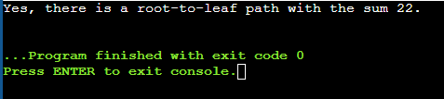

Question 8

#include <iostream>

#include <vector>

#include <unordered_map>

#include <algorithm>

using namespace std;

class UnionFind {

public:

vector<int> parent, rank;

UnionFind(int n) : parent(n), rank(n, 0) {

for (int i = 0; i < n; ++i) {

parent[i] = i;

}

}

int find(int x) {

if (x != parent[x]) {

parent[x] = find(parent[x]);

}

return parent[x];

}

void unite(int x, int y) {

int rootX = find(x);

int rootY = find(y);

if (rootX != rootY) {

if (rank[rootX] > rank[rootY]) {

parent[rootY] = rootX;

} else if (rank[rootX] < rank[rootY]) {

parent[rootX] = rootY;

} else {

parent[rootY] = rootX;

rank[rootX]++;

}

}

}

};

int numberOfGoodPaths(vector<int>& vals, vector<vector<int>>& edges) {

int n = vals.size();

vector<vector<int>> adj(n);

for (const auto& edge : edges) {

adj[edge[0]].push_back(edge[1]);

adj[edge[1]].push_back(edge[0]);

}

vector<int> sortedNodes(n);

iota(sortedNodes.begin(), sortedNodes.end(), 0);

sort(sortedNodes.begin(), sortedNodes.end(), [&](int a, int b) {

return vals[a] < vals[b];

});

UnionFind uf(n);

unordered_map<int, int> count;

int goodPaths = 0;

for (int node : sortedNodes) {

int nodeValue = vals[node];

count[nodeValue]++;

goodPaths++;

for (int neighbor : adj[node]) {

if (vals[neighbor] <= nodeValue) {

uf.unite(node, neighbor);

}

}

unordered_map<int, int> componentCount;

for (int neighbor : adj[node]) {

if (vals[neighbor] <= nodeValue) {

int root = uf.find(neighbor);

componentCount[root]++;

}

}

for (auto& [_, size] : componentCount) {

goodPaths += size * (size - 1) / 2;

}

}

return goodPaths;

}

int main() {

vector<int> vals = {1, 3, 2, 1, 3};

vector<vector<int>> edges = {{0, 1}, {0, 2}, {2, 3}, {2, 4}};

cout << "Number of good paths: " << numberOfGoodPaths(vals, edges) << endl;

return 0;

}

Output:

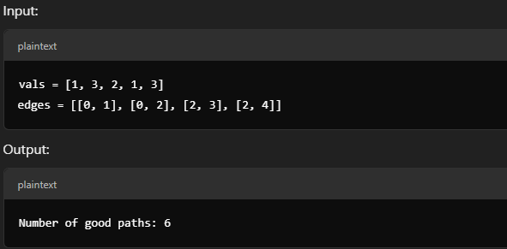

Question 9

#include <iostream>

#include <vector>

#include <algorithm>

using namespace std;

int dfs(int node, const vector<vector<int>>& adj, const string& s, int& maxPathLength) {

int longest = 0, secondLongest = 0;

for (int neighbor : adj[node]) {

int childPath = dfs(neighbor, adj, s, maxPathLength);

if (s[node] != s[neighbor]) {

if (childPath > longest) {

secondLongest = longest;

longest = childPath;

} else if (childPath > secondLongest) {

secondLongest = childPath;

}

}

}

maxPathLength = max(maxPathLength, longest + secondLongest + 1);

return longest + 1;

}

int longestPath(vector<int>& parent, string s) {

int n = parent.size();

vector<vector<int>> adj(n);

for (int i = 1; i < n; ++i) {

adj[parent[i]].push_back(i);

}

int maxPathLength = 0;

dfs(0, adj, s, maxPathLength);

return maxPathLength;

}

int main() {

vector<int> parent = {-1, 0, 0, 1, 1, 2};

string s = "abacbe";

cout << "Longest path length: " << longestPath(parent, s) << endl;

return 0;

}

Output:

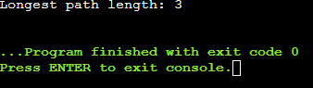

Question 10

#include <iostream>

#include <vector>

#include <numeric>

using namespace std;

class Solution {

public:

int maxComponents = 0;

int dfs(int node, const vector<vector<int>>& adj, const vector<int>& values, vector<bool>& visited, int k) {

visited[node] = true;

int subtreeSum = values[node];

for (int neighbor : adj[node]) {

if (!visited[neighbor]) {

subtreeSum += dfs(neighbor, adj, values, visited, k);

}

}

if (subtreeSum % k == 0) {

maxComponents++;

return 0;

}

return subtreeSum;

}

int componentValue(int n, vector<vector<int>>& edges, vector<int>& values, int k) {

vector<vector<int>> adj(n);

for (const auto& edge : edges) {

adj[edge[0]].push_back(edge[1]);

adj[edge[1]].push_back(edge[0]);

}

vector<bool> visited(n, false);

int totalSum = dfs(0, adj, values, visited, k);

if (totalSum % k == 0) {

maxComponents++;

}

return maxComponents;

}

};

int main() {

Solution sol;

int n = 5;

vector<vector<int>> edges = {{0, 1}, {1, 2}, {1, 3}, {3, 4}};

vector<int> values = {1, 2, 3, 4, 5};

int k = 3;

int result = sol.componentValue(n, edges, values, k);

cout << "Maximum number of components: " << result << endl;

return 0;

}

Output:

